|  |  |
| --- | --- |
| \\VFILERDPI\DPI-Home\OBRIENR2\My Documents\Downloads\PP logo.jpg | file:///M:/Jerilderie/Public/Website/Murrumbidgee%20Council%20Intranet/web-content/Logo/MC_Primary%20Logo.jpg |
| **DEVELOPMENT ASSESSMENT REPORT**  for  **WESTERN REGIONAL PLANNING PANEL** | |

|  |  |
| --- | --- |
| DA number | DA 21/2023 |
| Type of development | Regionally significant development (as per Schedule 7, clause 5 of State Environmental Planning Policy (Planning Systems) 2021. |
| Proposed development | Electricity generating development (private infrastructure) |
| Brief description | The installation of 11,340 solar panels and associated infrastructure including a high voltage switchboard, inverter station, eight (8) BESS containers, poles and ancillary fencing and landscaping. |
| Capital investment value | $8,072,500 |
| Property | Lots 27 DP 750904, 415 Macleay Road, Coleambally |
| Applicant | Green and Gold Energy |
| Land owner | SJ & M Burgess |
| Relevant environmental planning instruments | Murrumbidgee Local Environmental Plan 2013  State Environmental Planning Policy (Planning Systems) 2021  State Environmental Planning Policy (Transport & Infrastructure) 2021 |
| Clause 4.6 requests | Nil |
| Submissions | One (1) submission from Essential Energy – no objection. |
| Documents submitted with application | Statement of Environmental effects incorporating the following appendices:   * Aboriginal Cultural Heritage Due Diligence Assessment * Agricultural Impact Assessment * Biodiversity Impact Assessment * CIV Report * Construction Environmental Management Plan * Glint and Glare Assessment Report * Landscape Plan * Traffic Impact Assessment * Solar Panel & Power Station details * Draft VPA |
| Date of lodgement | 9 June 2023 |
| Assessment officer | Mr SJ Parisotto, Senior Planner – Murrumbidgee Council |
| Recommendation | **APPROVAL** |

**PART 1: EXECUTIVE SUMMARY**

* 1. **Determining authority**

The application has been referred to the Western Joint Regional Planning Panel (‘WJRPP’) for determination on the basis that the capital investment value (‘CIV’) exceeds the threshold set out in Schedule 6, clause 5 of State Environmental Planning Policy (Planning Systems) 2021 (‘PS-SEPP’).

A briefing paper was presented to the WJRPP on 19 September 2023.

* 1. **Outline of development**

The proposal is for proposal is for an electricity generating development involving the following:

1. Installation of a photovoltaic (PV) solar array comprising 11,340 panels with a capacity of sub 4.95 Megawatts (MW);
2. Installation of battery energy storage system (BESS) comprising eight containers each with a storage capacity of up to 2.75 MWh;
3. Installation of electrical collection systems including a high voltage switchboard, an inverter station and associated structures.

A copy of the submitted documents are contained in **Schedule 1**.

* 1. **Site context**

|  |  |
| --- | --- |
| Locality | 12km north of Coleambally |
| Development site | Lots 27 DP 750904 |
| Existing Land Use | Agriculture, comprising of irrigated crop including associated irrigation infrastructure, grazing and poultry farm and other farm buildings |
| Development Footprint | 13ha |
| Setting | Irrigated farm land with their associated irrigation infrastructure, dwellings, farm buildings |
| Environment | Highly disturbed as a result of agricultural activities |

* 1. **Statutory considerations**

The proposed development accords with the provisions of the relevant environmental planning instruments and is permissible within the RU1 Primary Production zone of Murrumbidgee Local Environmental Plan 2013 (‘MLEP’) through the provisions of clause 2.36(1)(a) of State Environmental Planning Policy (Transport and Infrastructure) 2021 (‘T&I-SEPP’)

* 1. The development application was notified in accordance with the Environmental Planning and Assessment Regulation, 2021 (‘EP&A Regulation’) and Murrumbidgee Council’s Community Participation Plan (‘CPP’). No submissions were received.
  2. The application was referred to Essential Energy (‘EE’). Their concerns have been addressed by way of revised plans.
  3. The development application has been referred to the WJRPP with a recommendation for approval. A copy of the recommended conditions are set out in **Schedule 2**.

[This section has been deliberately left blank]

**PART 2: PROPOSED DEVELOPMENT**

2.1 The development involves the construction and operation of a micro solar farm with a maximum export capacity to the grid of 5 MW.

1. Installation of 11,340 ground mounted photovoltaic (PV) solar modules on single axis trackers, with a capacity of 4.95 Megawatts (MW) AC. The panels are 2.2m in length by 1.1 metres in width and are supported on 1.4m high poles. When at full tilt the panels are approximately 2.7m in height. The panels are installed in rows of 27, with each row being approximately 95 metres in length. There are 420 rows each spaced at 6.0m.

**Figure 1 – Solar panels and tracker**[1]

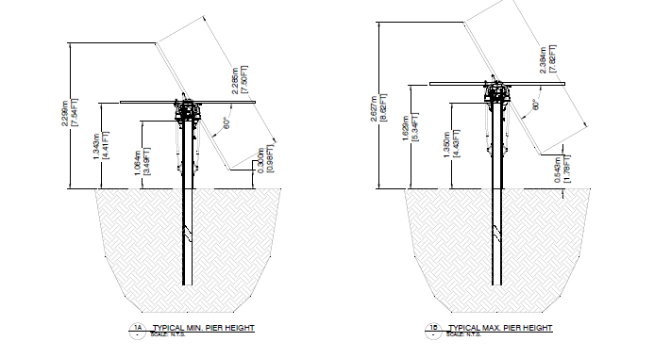

**Figure 2 – Solar panel array layout**[2]

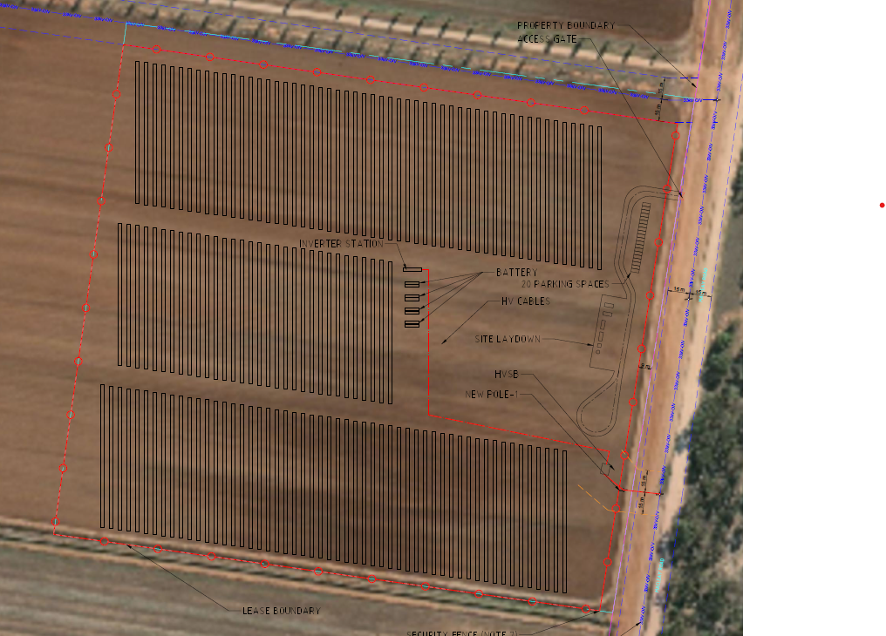

1. Installation of eight (8) battery energy storage system (BESS) each with a storage capacity of 2.75 MWh and associated components (total capacity 22MWh). The containers are 9.3 metres in length, 1.7 metres in width and 2.6 metres in height.

**Figure 3 – Battery container**[3]

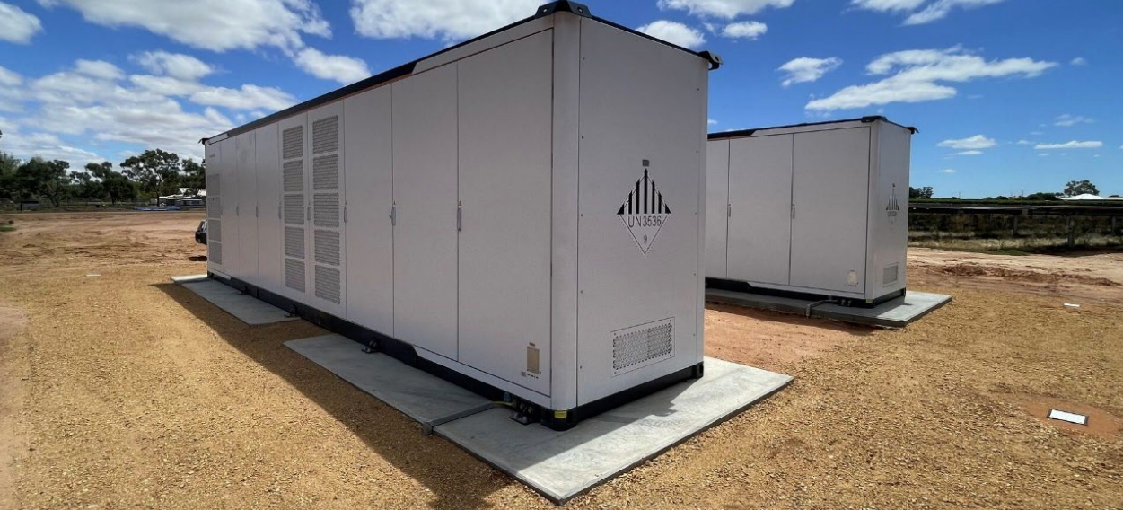

1. Electrical collection systems including switch room, control room and inverter station;

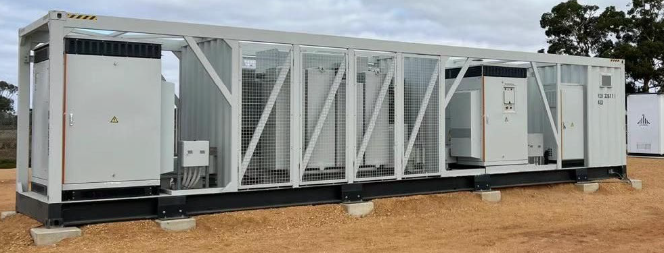**Figure 4 – Central Inverter**[4]

[This section has been deliberately left blank]

1. 1800mm chain wire fencing to secure the new plant.

**Figure 5 – Fencing**[5]

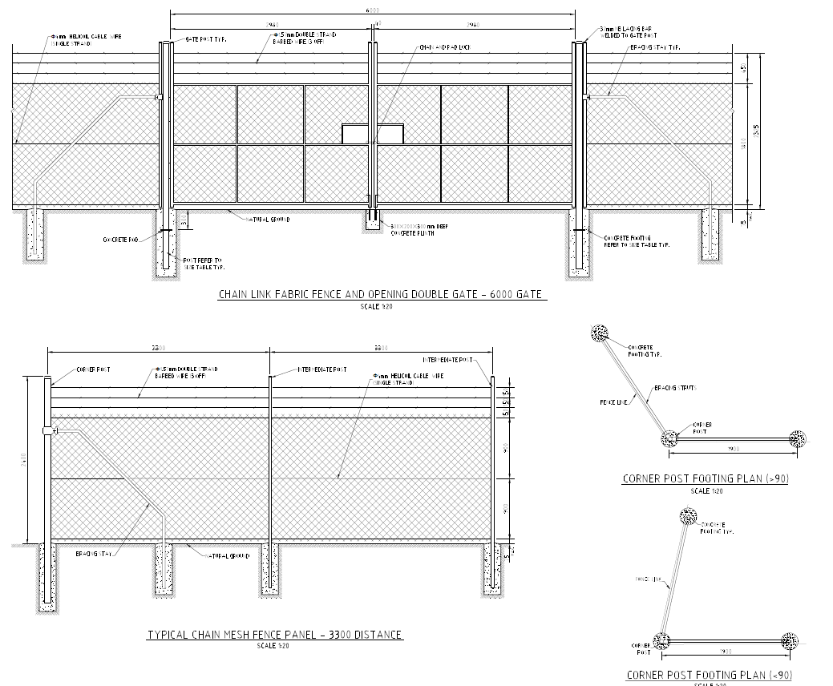

1. High voltage (HV) electrical switchgear to connect the existing privately owned HV electricity network.

**Figure 6 – High voltage switch board**[6]

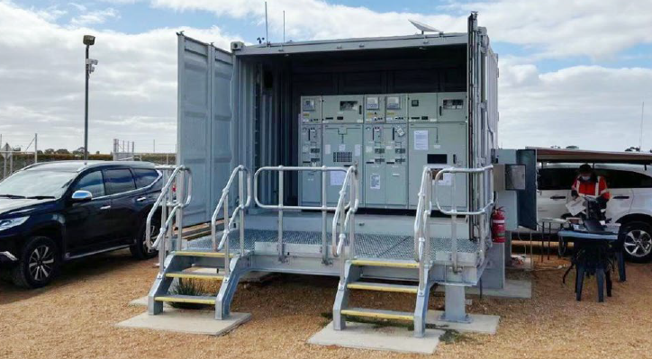

1. A temporary construction hub including demountable offices, amenities, equipment laydown areas and vehicle parking facilities.

2.2 The development is for electricity generating infrastructure by a private company with a CIV of $8,072,500. It is a type of development referred to in Schedule 6, clause 5 of the PS-SEPP and declared to be regionally significant. Consequently, the development application cannot be determined by Murrumbidgee Council and the matter is required to be determined by the WJRPP.

[This section has been deliberately left blank]

**PART 3: SITE & LOCALITY**

3.1 The proposed electricity generating facility will have a footprint of approximately 7ha and will be constructed on Lot 27 DP 750904, 415 Macleay Road Coleambally, approximately 12 km north-west of Coleambally in the Murrumbidgee local government area.

**Figure 7 – Locality and site plan**[7]

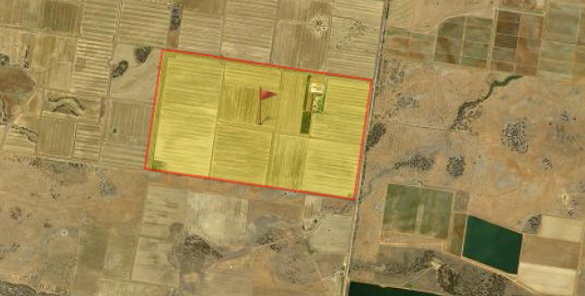

**Figure 8 – Looking south-west at proposed location of solar arrays**[8]

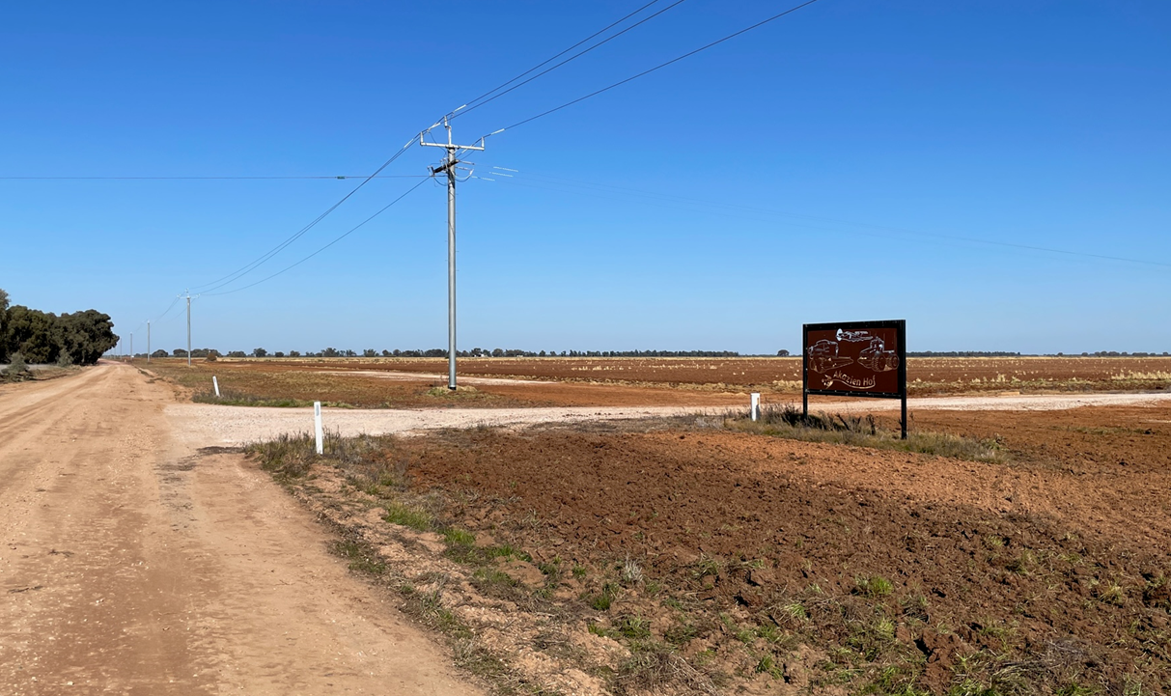

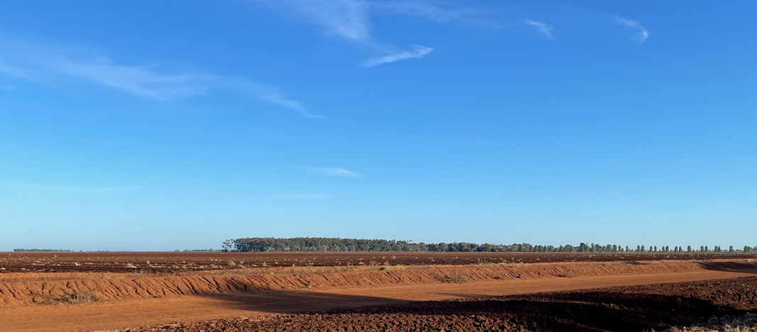**Figure 9 – Looking north-west at proposed location of solar arrays**[9]

3.2 The terrain levels across the entire property is generally flat with a slight fall towards Macleay Road.

3.2 The site forms part of a large holding, comprising Lots 24-27 DP 750904 and Lot 1 DP 1282716, which has a total area of 518ha. The property comprises of approximately 480ha of laser levelled irrigation land; a homestead with associated farm buildings, 6ha of a native tree plantation, and approximately 18 hectares of internal roadways and irrigation channels. The property is largely unfenced.

3.4 The site in a rural locality characterised by both dry land and irrigation farms, including associated infrastructure such as water supply and drainage channels and irrigation bridges over roads. The nearest dwelling being located approximately 3.0km to the north of the development area.

3.5 Overhead power lines run north - south along the Macleay Road, east - west passes through the site.

**Figure 10 – Looking north-west at proposed location of solar arrays**[10]

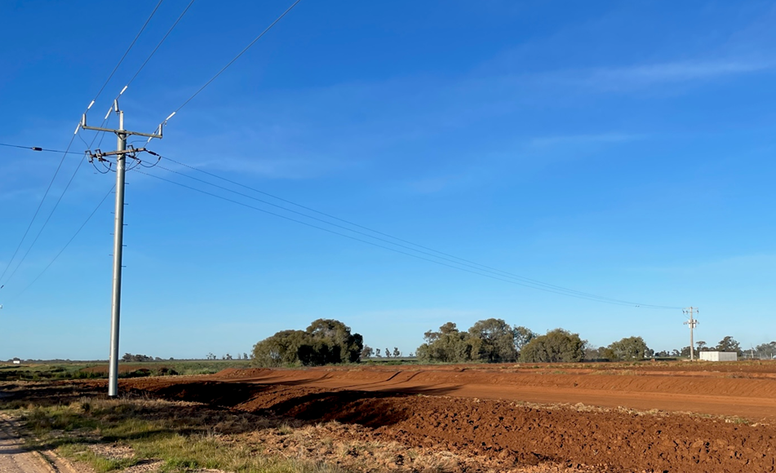

**PART 4: STATUTORY CONSIDERATIONS**

4.1 Section 4.15(1) of the *Environmental Planning and Assessment Act 1979* (‘EP&A Act’) outlines the matters which the consent authority must take into consideration when determining a development application. These matters as are of relevance to the development application include the following:

1. *the provisions of any environmental planning instrument, proposed instrument, development control plan, planning agreement and the regulations*
2. *the likely impacts of that development, including environmental impacts on both the natural and built environments, and social and economic impacts in the locality,*
3. *the suitability of the site for the development,*
4. *any submissions made in accordance with this Act or the regulations,*
5. *the public interest.*

4.2 The proposed development does not fall within the categories of designated or integrated development and there are no concurrence authorities.

4.3 The following environmental planning instruments have been deemed relevant to this application:

* *State Environmental Planning Policy (Planning Systems) 2021*
* *State Environmental Planning Policy (Transport and Infrastructure) 2021*
* *State Environmental Planning Policy (Primary Production) 2021*
* *Riverina Murray Regional Plan 2036*
* *Murrumbidgee Local Environmental Plan 2013*

4.4 *State Environmental Planning Policy (Planning Systems) 2011* applies to the proposal as it identifies if development is regionally significant development as the proposed CIV threshold identified in Schedule 6, clause 5 of PS-SEPP has been exceeded. As a result, the application is to be referred to and determined by the WJRPP.

4.5 *State Environmental Planning Policy (Transport and Infrastructure) SEPP*

4.6 Part 2.33, Division 4 Clause 2.36 (1)(b) of the *State Environmental Planning Policy (Transport and Infrastructure)* enables development for the purpose of an electricity generating works to be carried out with development consent in a prescribed rural zone. Accordingly, the proposed solar farm (which is a photovoltaic electricity generating system) is permissible with development approval.

4.7 Part 2.3 Division 5, clause 2.48 of the T&I-SEPP requires consultation with Essential Energy as the proposal may impact electricity transmission or distribution. Given the type of the development and the proposed works, the electricity supply authority, EE, were notified and provided with an opportunity to comment on the proposal. Their comments are set out in **Schedule 3**. In summary they raised no objections to the development.

4.8 The proposed development is not located on or close to a classified road nor does it meet or exceed the thresholds identified in the Column of the Table to Schedule 3 and therefore referral to the Transport for NSW was not required under Part 2.3 Division 17 Subdivision.

4.9 The *State Environmental Planning Policy (Primary Production)* 2021 (‘PP-SEPP’) aims to facilitate the orderly and economic use of rural land for continued agricultural production as well as prevent land fragmentation and reduce the potential for land use conflict.

The footprint of the solar farm is approximately 13ha and this area is proposed to be enclosed with a perimeter fence. The development site will not be subdivided and the land therefore not permanently fragmented so as to potentially exclude it or increase the likelihood of it being alienated for productive agriculture into the future.

The proposal is consistent with the PP-SEPP.

4.10 The *Riverina Murray Regional Plan 2036* (‘RMRP’) provides a vision for the future of the Riverina Murray. The RMRP recognises amongst a number of matters the potential for growth of the renewable energy industry within the region with renewable energy identified as a priority growth sector. Direction 1 of the RMRP is to protect the region’s diverse and productive agricultural land.

Direction 11 of the Plan is to promote the diversification of energy supplies through renewable energy generation. The Plan recognises Transgrid’s NSW Connection Opportunities identified Darlington Point as a location with capacity for renewable energy generation. Leveraging renewable energy opportunities for the long-term sustainability of the region depends on adopting a strategic approach to new projects and incorporating small-scale cogeneration measures into the design of new developments.

4.11 The relevant local environmental plan applying to the site is the *Murrumbidgee Local Environmental Plan 2013* (MLEP).

4.12 The aims of the MLEP include:

* *The protection, enhancement and conservation of agricultural and horticultural land through the proper management, development and conservation of natural and man-made resources, and*
* *The promotion of the efficient and equitable provision of public services, infrastructure and amenities.*

The proposal is consistent with these aims as a solar farm facilitates the conservation of energy and renewable resources while ensuring that the lands continuing use for productive agriculture is not diminished.

4.13 The site is located within the RU1 Primary Production Zone pursuant to clause 2.2 of the MLEP.

**Figure 11 – Extract for MLEP 2013 Zoning Map**[11]

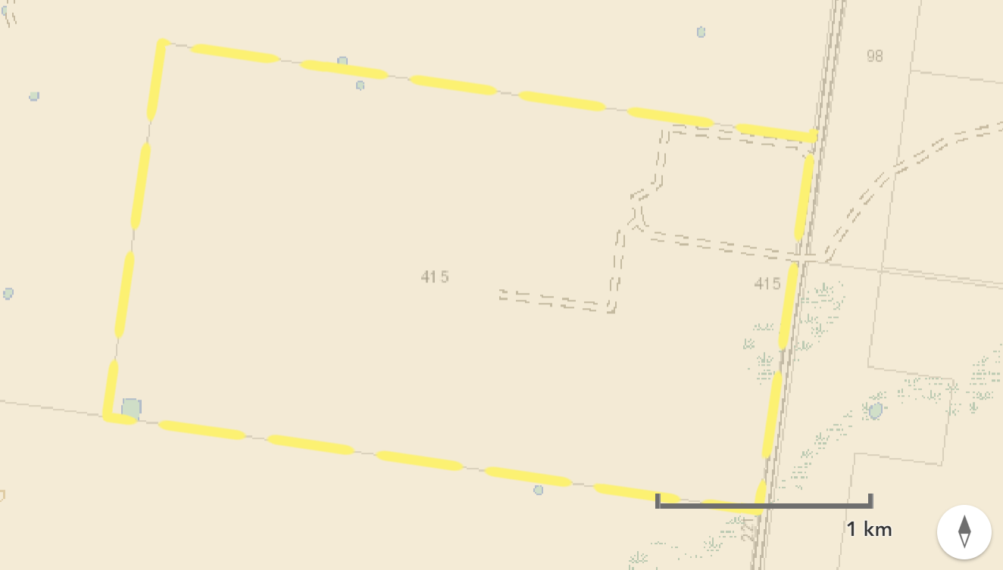

4.14 The proposed development is defined as an *electricity generating works* under the standard instrument, being.

***Electricity generating works*** *means a building or place used for the purpose of—*

1. *making or generating electricity, or*
2. *electricity storage.”*

*Electricity generating works* are a prohibited use in RU1 zone of the Land Use Table in Clause 2.3.

As identified in paragraph 4.6 the provisions of the T&I SEPP enable a consent authority to approve *electricity generating works* and the provisions of Part 2.33 of the policy.

4.15 The zone objectives include the following (pursuant to the Land Use Table in clause 2.3):

* *Encourage sustainable primary industry production by maintaining and enhancing the natural resource base.*
* *Encourage diversity in primary industry enterprises and systems appropriate for the area.*
* *Minimise the fragmentation and alienation of resource lands.*
* *Minimise land use conflict*

In considering the applicant’s Statement of Environmental Effects (‘SoEE’), Council is satisfied that the proposed development accords with the zone objectives in that:

* The project has an anticipated life span of thirty (30) years upon which decommission of the site will be undertaken, development will be designed and operated to maintain the resource base. Upon decommissioning the site will be rehabilitated and agricultural activities would be able to continue.
* The solar farm will encourage diversity in technologies to take advantage of renewable energy and facilitate development at an expected lower economic (site specific) and environmental (broadly) costs.
* The development will not result in fragmentation of agricultural land by subdivision.
* The development has been sympathetically designed and will have measures in place to control and manage environmental impacts so that there will be minimal potential for land use conflict.

4.16 MLEP 2013 also provides directions and controls relating to development standards, miscellaneous provisions and local provisions that are considered below.

|  |  |
| --- | --- |
| *Clause* 5.10 Heritage  The objectives relate to the conservation of built and historic heritage, places of significance and aboriginal objects. | There are no items of built heritage on the development site. A due diligence assessment was carried out in accordance with the *Due Diligence Code for the Protection of Aboriginal Objects in NSW.* This identified that because the development site was disturbed agricultural land that further on site investigation was not warranted.  The development is capable of meeting the objectives of this clause provided that in the event an aboriginal object or relic is encountered, work cease and if necessary a Heritage Impact Permit be obtained if required.  In order to address the potential for unexpected discoveries a number of conditions have been recommended – refer to conditions 7 and 21 in Schedule 2. |
| *Clause 5.21 Flood planning*  The objectives relate to minimising flood risk to life and property and ensuring that the development of land was commensurate with the flood hazard, and to ensure safe evacuation and avoid cumulative impacts on flooding and the environment. | The land is not known to have been affected by flooding and is not identified as being within a Flood Planning Area. There is a low possibility of the development being affected by flooding or resulting in flood-related impacts. The development complies with this clause. |
| *Clause 6.1 Earthworks*  The objectives relate to ensuring that earthworks will not detrimentally impact on environmental functions and processes, neighbouring uses, cultural or heritage items or features of surrounding land. | Earthworks are also required to provide the construction zone, car parking area, fill for building pads, excavation for pile driven footings, the establishment of landscaping and the erection of fences. The development is capable of complying with the objectives of this clause provided that conditions are imposed for erosion and sediment control, protection of aboriginal heritage and sustainable land management taking into account soil physical and chemical properties and protection of biodiversity. Earthworks would be carried out in accordance with *AS3798-2007 Guidelines on earthworks for commercial and residential developments.* |
| *Clause 6.3 Terrestrial Biodiversity*  The objectives are to maintain terrestrial biodiversity by the protection of native fauna and flora and encouraging their conservation and their habitats and protecting ecological processes. | The map set out in Figure 12 identifies that part of the property, along the eastern boundary of the site to be developed has been mapped as being an area of biodiversity and therefore the provisions of this clause must be taken into consideration.  **Figure 12 – MLEP Terrestrial Biodiversity[12]**    It is noted that the land to be developed has not been identified on the Biodiversity Values Map (Non-EPI).  The applicant has undertaken a Biodiversity Values Assessment Report identified that the proposed development site contained primarily non-native vegetation, biodiversity would not be impacted and a Biodiversity Development Assessment Report was not required.  The report identified that the site is highly disturbed and completely cleared due to a long history of intensive agricultural and farming practices. There are no trees or grasses within the development footprint as this land has been historically used for cropping.  There are no threatened ecological communities, nor were there any threatened species recorded in the project site.  The consent authority may be satisfied that the proposed development accords with the provisions of clause 6.3 of MLEP 2013 in that it will:   * not have an adverse impact on the condition, ecological value and significance of the fauna and flora on the land, and * not have any adverse impact on the importance of the vegetation on the land to the habitat and survival of native fauna, and   Further the development does not result in any potential to fragment, disturb or diminish the biodiversity structure, function and composition of the land, nor have adverse impact on the habitat elements providing connectivity on the land, and  Given the current use of the land and nature of works associated with the development it is unlikely that the development would have an impact on local native ecological communities, flora or fauna and their habitats. |
| *Clause 6.4 Groundwater vulnerability*  The objectives are to ensure the maintenance of key groundwater systems and protect groundwater resources from contamination arising from development. | The development site, as is much of the local government area has been mapped as being in a groundwater vulnerable area.  The development does not involve the use or consumption of groundwater resources and will not result in its depletion. There is the potential for degradation of groundwater to occur through leaching of chemicals that may be utilised on site and through nutrients from chemical application and from stock.  The development is capable of complying with the objectives of this clause provided that conditions are imposed regulating the storage and use of chemicals or other toxic materials and the appropriate management of stock, weeds and pasture.  Appropriate conditions have been included within the recommended conditions of consent (Condition 37 of Schedule 2). |
|  |  |
| *Clause 6.9 Essential Services*  This clause requires the consent authority to be satisfied that services essential for the development are provided-:water, electricity, storm water drainage sewage management and vehicular access | The proposed development will not require the provision of a potable water supply nor a permanent onsite waste management system. Temporary sanitary facilities, and tanked potable water will be provided during construction.  Electricity is currently provided to the site.  Access to the site is via a series of all-weather gravel roads which connect to the Kidman Way to the west..  Appropriate conditions have been included within the recommended conditions of consent – refer to conditions 8 of Schedule 2.  Condition 29c sets down water storage requirements for fire fighting purposes. |

4.17 The provisions of section 4.15(1)(a)(ii) require a consent authority to take into consideration any draft environmental planning instrument. In this instance there are no proposed environmental planning instruments that have been the subject of public consultation, that have relevance to this development proposal.

4.18 The provisions of section 4.15(1)(a)(iii) require a consent authority to take into consideration any draft environmental planning instrument. The only development control plan that is in force, is *Murrumbidgee Development Control Plan 1995 Village* (‘DCP’). This DCP only applies to the village areas of Darlington Point and Coleambally and consequently is not relevant, nor does it apply to this rural zoned development site.

4.19 Although not falling in the category of a development control plan, the provisions of *Murrumbidgee Council Development Contributions Plan Section 7.12 Environmental Planning and Assessment Act 1979* are an instrument that may be considered. Should the provisions of the contributions plan be applied, the required contribution is 1% of the project cost which is $80,725.00.

An appropriate condition has been included within the recommended conditions of consent (see condition 9c of Schedule 2).

4.20 The applicant has offered to enter into a voluntary planning agreement, which was raised at the Briefing Hearing on 18 September 2023. At the direction of the WRPP it was recommended that a resolution of Council be sought seeking direction as to whether a planning agreement would be accepted.

Council resolved not enter into a voluntary planning agreement with the applicant for DA 21/2023 (PPSWES-190, 415 Macleay Rd, Coleambally for the following reason

1. Due to uncertainty with future development activities and the rate development that will occur in the local government area, ad hoc approach to voluntary planning agreements reduces Council’s ability to provide community facilities in accordance with its s7.12 contribution plan.

4.21 The provisions of section 4.15(1)(a)(iv) require the consent authority to take into consideration the provision of any regulation. In this instance there are no regulations of relevance to the proposed development.

## 

## 4.22 The likely impacts of development section 4.15(1)(b), including environmental impacts on both the natural and built environments and social and economic impacts in the locality have been addressed throughout the report, and in the following table.

**Table 1: Likely Impacts of proposed development**

|  |  |
| --- | --- |
| *Context and setting* | The development is compatible with its context and setting. The 13ha footprint is small in scale when compared to other larger solar farms that have been approved in the local government area. Further the solar panels and associated structures are sited away from main roads and sensitive receptors so as to be visually unobtrusive. The size of the solar arrays, their configuration and height, typically less than 4.0m would not dominate the locality in terms of mass, bulk and density.  The development is considered to have minimal impact on the rural setting in which it is proposed. |
| *Access* | Access to the development site is via the Macleay Road is a local all-weather gravel road.  Access to the site will have to be upgraded and a condition of consent has been imposed to this effect. |
| *Traffic* | The applicant has provided a Traffic and Transport Impact Assessment prepared by Traffic Works, which suggests that there is no engineering reasons why the development should not be approved, and recommends:   * the a minimum of 20 car parking spaces be provided for the construction phase (as per the plans) * The subject site access be constructed per AS/NZS 2890.2 to the satisfaction of the Council. * A dilapidation report is undertaken by a qualified professional to determine the suitability of Macleay Road and Ercildoune Road to accommodate the heavy vehicle volumes generated during the construction phase of the development.   The recommendations, in particular points two and three have been included as conditions of consent (see conditions 12A, 25A & 26A in Schedule 2). It should be noted that the applicant was not informed of these conditions in the draft set of conditions they were provided with.  From an operation perspective, the traffic generated by the development is negligible, as monitoring is undertaken remotely. For maintenance purposes, light vehicles would access the site every six months. |
| *Air Quality* | It is anticipated that dust may be generated as a consequence of on-site construction activities as well as from vehicles using internal roads. It is considered that the applicant can implement mitigation measures to reduce the likelihood and extent of dust nuisance, including using a water cart to spray down surfaces in windy conditions and the measures mentioned above relating to road pavement.  Amenity impacts are addressed in the Construction Management Plan (CEMP) and compliance with that plan is required by Condition 14 of Schedule 2. |
| *Visual amenity, glare & public domain* | The development is proposed in a sparsely populated and relatively isolated rural location, on flat ground and well setback from any public road and property boundaries. The structures are not overwhelming in their height and dimensions and the visual impact is minimal. Although the applicant is proposing to provide a landscape buffer, no condition has been imposed requiring it to be done.  The solar panels are non-reflective and the fixed tracking system of the panels will minimise the incidence and potential for glare. Given the location away from classified roads and nearby dwellings the visual impact to sensitive receptors and the public domain is considered to be acceptable.  Several conditions have been recommended address amenity impacts – refer to conditions 29A, 31, 32, 32A & 33 of Schedule 2.  It should be noted that conditions 29A and 32A were not included in the draft conditions provided to the applicant. |
| *Noise & vibration* | The nearest residential receptor not associated with the site is located approximately 3km to the north of the development area and as such is unlikely to be impacted as a result of noise and vibration during construction nor from operational aspects of the development.  To mitigate any potential nuisance, especially from construction activities and deliveries construction is to be limited to day time hours.  Mitigation of potential noise impacts in terms of construction and operation have been addressed by conditions 18, 30 & 34. |
| *Biosecurity* | The primary biosecurity issue associated with the development is around the management of weeds in and around the development site including the road reserve. Weeds if allowed to spread have the potential to impact extensive areas of land.  It is not expected of the development to take responsibility for weed control, it is considered reasonable that the site be managed in accordance with the principles of the Australian Weeds Strategy 2017-2027 during construction, and implement measures that would mitigate the off-site migration of weeds as a result of vehicle movements.  The applicant has indicated that by implementing vehicle hygiene protocols would assist with the control of the spread of weeds.  Conditions 21 and 32 of Schedule 2 provide a broad means of addressing potential spread of weeds. |
| *Water Resources* | The contamination of surface or ground waters is unlikely to be detrimentally affected as a result of the proposed development. |
| *Biodiversity* | The impacts to flora and fauna have been considered with reference to *Clause 6.3 Terrestrial Biodiversity* in paragraph 4.16 of this report.  There are expected to be minimal impacts to biodiversity on and near the development site. |
| *Heritage* | The subject site does not contain any heritage item identified in MLEP 2013, nor have any sites or places containing Aboriginal cultural heritages been identified in the Aboriginal Heritage Information Management System (‘AHIMS’).  The applicant has undertaken a Due Diligence Assessment prepared in accordance with the Department of Environment and Climate Change (2010) *Due Diligence Code of Practice for the Protection of Aboriginal Objects in NSW* which concludes that because the site is disturbed agricultural land there is little likelihood of discovering Aboriginal artefacts.  While the potential for discovery is low, it is important that the chance finds procedure protocols be included as a condition of consent to ensure the protection of aboriginal heritage during construction. |
| *Other land Resources* | The development is not in a water catchment area nor known to contain significant minerals or other geological resources. The lifespan of the development is estimated at 30 years after which the development will be decommissioned and the land rehabilitated to its natural state so that it can continue to be used for productive agriculture. There are no known other land resources that are likely to be affected.  To ensure consistency with similar applications conditions have been included within the recommended conditions of consent (see 28 & 38 of Schedule 2). |
| *Utilities* | Essential services that are considered suitable and necessary for the development will be provided. This includes property access, power (generator), water supply (tank), and sewage disposal. |
| *Waste* | Waste generated through the construction phase will be removed from the site and either recycled, or disposed of resource recovery or waste management facility. Murrumbidgee Council has previously had issues with large volumes of waste from solar farms being deposited in local landfills with limited capacity.  In line with recent approvals, Murrumbidgee Council will not accept construction waste at any of its waste management facilities.  The ongoing operation of the solar farm is not likely to result in waste generation and at the end of life, the development will be decommissioned and all infrastructure removed from the site and where possible recycled or reused.  Appropriate conditions have been included within the recommended conditions of consent (see 16 and 25 Schedule 2). |
| *Natural hazards* | The subject site is not prone to natural hazards such as tidal inundation, subsidence, slip, mass movement, flooding nor is it mapped as being bushfire prone land.  Despite the land not being mapped as being bushfire prone land, all land is still subject to a level of bushfire risk.  The applicant in their Statement of Environmental Effects has undertaken a bushfire risk assessment addressing the relevant provisions the NSW Rural Fire Service *Planning for Bush Fire Protection Guidelines (2019)*, which incorporates a Bush Fire Emergency Management and Operations Plan (BFEMOP) submitted with the development application.  While the approach taken by the applicant are satisfactory, Council has recently reviewed its approach to the assessment of solar farms in order to address the general concerns raised by the local Rural Fire Brigades and used guidelines from the Victorian Country Fire Association in terms of onsite facilities to aid in fire-fighting. This has resulted in the development of a condition of consent to be imposed on solar farm developments.  Specific to this application will be the requirement to provide additional water storage for the proposed BESS of a minimum of 288,000lt in accordance with AS 2419.1-2021: Fire hydrant installations, Table 2.2.5(D). A tank of this capacity is typically 10.5 metres in diameter with a height of approximately 3.1 metres.  (See conditions 27c and 29 of Schedule 2) |
| *Technological hazards* | The development is subject to technological hazards associated with solar panels however, the risks are considered to be low.  The batteries used are lithium-ion type which are identified as a class 9 dangerous good, however are outside the scope of State Environmental Planning Policy (Resilience and Hazards) 2021 (‘R&H-SEPP’) in terms of threshold screening and pose little threat to people or property. |
| *Safety, security and crime prevention* | The development will have real-time remote monitoring allowing for constant surveillance without the need for on-site staffing. This will assist in responding quickly to emergencies.  The site and infrastructure will be secure, surrounded by a wire perimeter fence and security gate. |
| *Socio- economic* | The SoEE has identified that up to 20 people will be working at the site during the development construction phase (approximately 9 months) and that several local contractors will carry out minor maintenance works over the operational life.  There is a prediction that additional employment opportunities may eventuate from the supply of goods and materials that will be required to support the construction. |
|  |  |
| *Site design* | The solar farm has been designed so that it is fit for purpose while minimising environmental impacts. |
| *Construction* | A range of potential impacts from construction have been identified throughout this assessment report and are either addressed in the applicant’s CEMP or can be addressed through conditions of consent.  Several conditions have been imposed, including adhering to the submitted CMP (see conditions 14-18 of Schedule 2). |
| *Hours of Operation* | The hours of operation of the development has already been discussed above under *Noise and Vibration*. The recommended hours for construction work are 7am-6pm weekdays, 8am-1pm Saturday and no work on Sunday and public holidays. The developer has indicated that non-intrusive activities may occur outside these hours from time to time.  See condition 17 Schedule 2, which enables the applicant to seek a variation to the approved construction hours. |
| *Buildings* | The BESS containers are not considered to be buildings because the submitted diagrams and details to demonstrate that the containers are not capable of being occupied, are prefabricated off site and is simply the housing of the inbuilt battery systems and as such the provisions of the BCA do not apply and a construction certificate is not required.  However, like other temporary structures and permanent buildings, they must be installed or founded so that they are able to resist the most critical loads and forces as per *AS1170:1,2,3 Structural Design Actions*. Plans submitted with the application show that each container is supported on pad footings.  Appropriate conditions have been included (refer to 4, 5, 6 & 13 of Schedule 2). |
| *Cumulative impacts* | Potential cumulative impacts have been considered to be insignificant. |
|  |  |

Based on the above there is unlikely to be any significant adverse impacts as a result of the development subject to the recommended imposition of conditions.

## 4.23 In terms of 4.15(1)(c) the proposed development site does not contain any significant constraints and can be appropriately serviced. Land restrictions, hazards and risks have been identified, can be reasonably controlled and managed and potential environmental impacts mitigated. The site is considered suitable and able to sustainably accommodate the solar farm development.

4.24 The provisions of the EP&A Regulation 2021 and Murrumbidgee Council’s Community Participation Plan (CPP) set down consultation, concurrence and advertising requirements for specific types of development applications and taking into consideration any submissions received in response to the notification process. In this instance, Council exhibited the development for a period of 28 days through the NSW Planning Portal, on Council’s website and adjoining landowners being informed by way of letter. Further, Council referred the application to EE for comment.

4.25 One (1) submission was received from EE. The submissions are set out in **Schedule 3**.

4.26 The submission from EE raised no objections to the development however require the following matters to be complied with:

1. *All structures associated with the development must be setback a minimum distance of 9m from the nearest part of the development to Essential Energy’s infrastructure (measured horizontally) is required to ensure that there is no safety risk from the overhead 33KV high voltage power lines located in the road reserve.*
2. *All structures associated with the development must be setback a minimum distance of 12.5m from the nearest part of the development to Essential Energy’s infrastructure (measured horizontally) is required to ensure that there is no safety risk from the overhead 33KV high voltage power lines.*
3. *All works are to comply with SafeWork clearance requirements. In this regard it is the responsibility of the person/s completing any works to understand their safety responsibilities. The applicant will need to submit a Request for Safety Advice if works cannot maintain the safe working clearances set out in the Working Near Overhead Power lines Code of Practice, or CEOP8041 - Work Near Essential Energy's Underground Assets.*
4. *If the proposed development changes, there may be potential safety risks and it is recommended that Essential Energy is consulted for further comment.*
5. *Any existing encumbrances in favour of Essential Energy (or its predecessors) noted on the title of the above property should be complied with.*
6. *Any activities within this location must be undertaken in accordance with the latest industry guideline currently known as ISSC 20 Guideline for the Management of Activities within Electricity Easements and Close to Infrastructure.*
7. *Prior to carrying out any works, a “Dial Before You Dig” enquiry should be undertaken in accordance with the requirements of Part 5E (Protection of Underground Electricity Power Lines) of the Electricity Supply Act 1995 (NSW). The location of overhead and underground power lines are also shown in the Look Up and Live app essentialenergy.com.au/lookupandlive.*

Appropriate conditions have been included within the recommended conditions of consent (refer to Condition 8 of Schedule 2).

4.27 The provisions of Section 4.15(1)(e) of the EP&A Act 1979 provides an overarching requirement to consider the public interest. It is considered that the public interest is best served by the consistent application of the requirements of the relevant Commonwealth and State government legislation, environmental planning instruments, development control plan, Council policy, and by Council ensuring that any adverse effects on the surrounding area and the environmental are avoided. On the basis that the proposed development is considered to be consistent with the aims and objectives of the relevant environmental planning instruments and policies; and Land and Environment Court Planning Principles, it is therefore unlikely to raise any issues that are contrary to the public interest.

[This section has been deliberately left blank]

**PART 5: CONCLUSION AND RECOMMENDATION**

5.1 The development application has been evaluated with regard to the matters for consideration listed in Section 4.15 of the Environmental Planning and Assessment Act 1979. On the basis of this assessment it is considered the proposal has merit and the development can be supported for the following reasons:

* The proposed development is permissible within the zone under State Environmental Planning Policy (Transport and Infrastructure) and is generally consistent with the aims, objectives and provisions of Murrumbidgee Local Environmental Plan 2013.
* The proposed development is consistent with the provision the relevant SEPPs that apply.
* The proposed development is unlikely to have any unreasonable impact on the environment, and where an adverse impact has been identified appropriate conditions have been imposed to mitigate the effects.
* The subject site is suitable for the proposed development.
* The proposed development does not raise any matter contrary to the public interest.

5.2 It is **recommended** that the Development Application DA No 21-2023 (PPSWES-190) for a solar farm and battery energy storage system and associated infrastructure at Lot 27 DP 750904, 415 Macleay Road, Coleambally, be **approved** pursuant to Section 4.16(1)(a) of the Environmental Planning and Assessment Act 1979 subject to conditions including those set out in **Schedule 2**.

1. Nextraker, Drawing M-201
2. ERM Project No. 0640174, Statement of Environmental Effects, Figure F3-1, 30 November 2022)
3. Chris Smith & Associates, Statement of Environmental Effects, p.8
4. Ibid, p.9
5. ACE Microgrid, Project No. GG21, drawing GG21-10-003-1
6. Chris Smith & Associates, Statement of Environmental Effects, p.9
7. SixMaps, downloaded 15 November 2023
8. © Steven Parisotto Photography, 2023 – images contained in Figure 8 taken on iPhone 12 on 3 August 2023
9. © Steven Parisotto Photography, 2023 – images contained in Figure 9 taken on iPhone 12 on 31 August 2023
10. ibid
11. NSW Planning Portal, Murrumbidgee LEP 2013 Zoning Map downloaded 31 August 2023
12. NSW Planning Portal, Murrumbidgee LEP 2013 Terrestrial Biodiversity Map downloaded 28 March 2023